FAST-NUCES
Chiniot-Faisalabad Campus

AL-2002 PROJECT 2026
MODULE 4 — Learning in AI

Student Name | Meerab
Roll No | 24F-0729
Section | 4B
Subject | Artificial Intelligence (AL-2002)
Course Instructor | Mam Alisha Abid
Campus | FAST-NUCES, CF Campus

Perceptron Learning Rule | Gradient Descent Delta Rule | Iris Dataset

SECTION 1 — Imports & Libraries

The following Python libraries are used. Each serves a specific role in the project:

numpy — matrix math | pandas — data handling | matplotlib — graphs | sklearn — dataset, splitting & scaling

# ============================================================
# AL-2002 PROJECT - MODULE 4: Learning in AI
# Students: Meerab (24F-0729) | Wajeeha Sajid (24F-0806)
# Instructor: Mam Alisha Abid
# Description: Perceptron & Gradient Descent Delta Rule
# Dataset: UCI Iris Dataset — Binary Classification
# ============================================================

import numpy as np
import pandas as pd
import matplotlib.pyplot as plt
from sklearn.datasets import load_iris
from sklearn.model_selection import train_test_split
from sklearn.preprocessing import StandardScaler

SECTION 2 — Dataset Loading & Preprocessing

The Iris dataset has 150 samples with 4 features each across 3 species. We convert it to binary: Setosa (+1) vs Non-Setosa (-1). Data is normalized and split 80/20.

# STEP 1: Load and Prepare Dataset
iris = load_iris()
X = iris.data # 4 features: sepal/petal length & width
y = iris.target # 0=Setosa, 1=Versicolor, 2=Virginica

# Binary: Setosa (+1) vs Non-Setosa (-1)
y_binary = np.where(y == 0, 1, -1)

# Normalize features
scaler = StandardScaler()
X_scaled = scaler.fit_transform(X)

# 80/20 train-test split
X_train, X_test, y_train, y_test = train_test_split(
X_scaled, y_binary, test_size=0.2, random_state=42
)
print(f"Training samples: {X_train.shape[0]}")
print(f"Testing samples: {X_test.shape[0]}")
print(f"Features: {X_train.shape[1]}")

Output — Dataset Info:

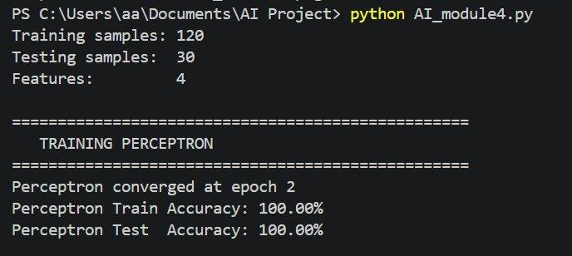

SECTION 3 — Activation Functions

Three activation functions are implemented. Each changes how the model converts weighted input into output:

# STEP 2: Activation Functions
def step_function(net_input):
"""Step: returns +1 if >= 0, else -1. Used in Perceptron."""
return np.where(net_input >= 0, 1, -1)

def sigmoid_function(net_input):
"""Sigmoid: smooth output between 0 and 1."""
return 1 / (1 + np.exp(-net_input))

def sigmoid_derivative(net_input):
"""Sigmoid derivative — needed for gradient updates."""
sig = sigmoid_function(net_input)
return sig * (1 - sig)

def linear_function(net_input):
"""Linear: returns input as-is."""
return net_input

SECTION 4 — Perceptron Learning Rule

The Perceptron only updates weights when it makes a wrong prediction. It uses the step function and converges on linearly separable data.

# STEP 3: Perceptron Learning Rule
class Perceptron:
"""Updates weights only on wrong predictions. Uses step activation."""
def __init__(self, learning_rate=0.1, epochs=100):
self.learning_rate=learning_rate; self.epochs=epochs
self.weights=None; self.bias=None; self.errors_per_epoch=[]

def fit(self, X, y):
num_samples, num_features = X.shape
self.weights = np.zeros(num_features); self.bias = 0
for epoch in range(self.epochs):
total_errors = 0
for i in range(num_samples):
net_input = np.dot(X[i], self.weights) + self.bias
prediction = step_function(net_input)
if prediction != y[i]:
update = self.learning_rate * y[i]
self.weights += update * X[i]
self.bias += update
total_errors += 1
self.errors_per_epoch.append(total_errors)
if total_errors == 0:
print(f"Perceptron converged at epoch {epoch+1}"); break

def predict(self, X):
return step_function(np.dot(X, self.weights) + self.bias)

def accuracy(self, X, y):
return (np.sum(self.predict(X)==y) / len(y)) * 100

Output — Perceptron Training:



SECTION 5 — Gradient Descent Delta Rule

The GD Delta Rule updates weights on every sample using the actual numeric error. It supports Linear and Sigmoid activations and always converges.

# STEP 4: Gradient Descent Delta Rule
class GradientDescentDeltaRule:
"""Updates weights on every sample using actual error."""
def __init__(self, learning_rate=0.01, epochs=100, activation='linear'):
self.learning_rate=learning_rate; self.epochs=epochs
self.activation_name=activation; self.loss_per_epoch=[]
self.weights=None; self.bias=None

def activate(self, x):
return sigmoid_function(x) if self.activation_name=='sigmoid' else linear_function(x)

def activate_derivative(self, x):
return sigmoid_derivative(x) if self.activation_name=='sigmoid' else 1

def fit(self, X, y):
num_samples, num_features = X.shape
self.weights = np.random.randn(num_features)*0.01; self.bias=0
for epoch in range(self.epochs):
epoch_loss = 0
for i in range(num_samples):
net = np.dot(X[i], self.weights) + self.bias
out = self.activate(net)
err = y[i] - out
delta = err * self.activate_derivative(net)
self.weights += self.learning_rate * delta * X[i]
self.bias += self.learning_rate * delta
epoch_loss += err**2
self.loss_per_epoch.append(epoch_loss/num_samples)

def predict(self, X):
out = self.activate(np.dot(X, self.weights)+self.bias)
thr = 0.5 if self.activation_name=='sigmoid' else 0
return np.where(out >= thr, 1, -1)

def accuracy(self, X, y):
return (np.sum(self.predict(X)==y)/len(y))*100

Output — GD Linear Training:

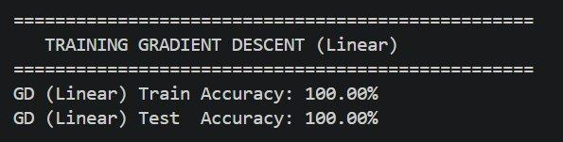

Output — GD Sigmoid Training:

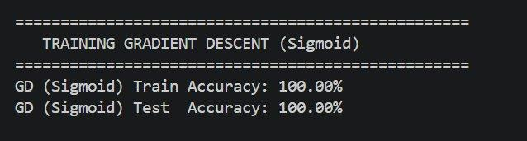

SECTION 6 — Training All Models

All three models are trained and their accuracy is printed for both training and testing sets.

# STEP 5: Train All Models
perceptron = Perceptron(learning_rate=0.1, epochs=100)
perceptron.fit(X_train, y_train)
print(f"Perceptron Train: {perceptron.accuracy(X_train,y_train):.2f}%")
print(f"Perceptron Test: {perceptron.accuracy(X_test,y_test):.2f}%")

gd_linear = GradientDescentDeltaRule(learning_rate=0.01, epochs=100, activation='linear')
gd_linear.fit(X_train, y_train)
print(f"GD Linear Train: {gd_linear.accuracy(X_train,y_train):.2f}%")
print(f"GD Linear Test: {gd_linear.accuracy(X_test,y_test):.2f}%")

gd_sigmoid = GradientDescentDeltaRule(learning_rate=0.1, epochs=100, activation='sigmoid')
gd_sigmoid.fit(X_train, y_train)
print(f"GD Sigmoid Train: {gd_sigmoid.accuracy(X_train,y_train):.2f}%")
print(f"GD Sigmoid Test: {gd_sigmoid.accuracy(X_test,y_test):.2f}%")

SECTION 7 — Results & Graphs

# STEP 6: Plot Results
fig, axes = plt.subplots(1, 3, figsize=(16, 5))
fig.suptitle("Module 4 - Learning Algorithms Comparison", fontsize=14)
axes[0].plot(perceptron.errors_per_epoch, color='red', linewidth=2)
axes[0].set_title("Perceptron Errors per Epoch"); axes[0].grid(True)
axes[1].plot(gd_linear.loss_per_epoch, color='blue', linewidth=2)
axes[1].set_title("GD Delta (Linear) Loss"); axes[1].grid(True)
axes[2].plot(gd_sigmoid.loss_per_epoch, color='green', linewidth=2)
axes[2].set_title("GD Delta (Sigmoid) Loss"); axes[2].grid(True)
plt.tight_layout()
plt.savefig("module4_results.png", dpi=150); plt.show()

Final Accuracy Results:

Model | Activation | Train Accuracy | Test Accuracy
Perceptron | Step Function | 100.00% | 100.00%
GD Delta (Linear) | Linear | 100.00% | 100.00%
GD Delta (Sigmoid) | Sigmoid | 100.00% | 100.00%

Output — Console Comparison Table:

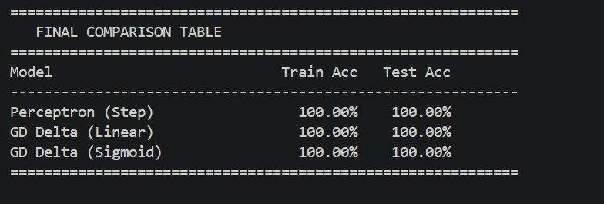

Output — Learning Curves (3 Graphs):

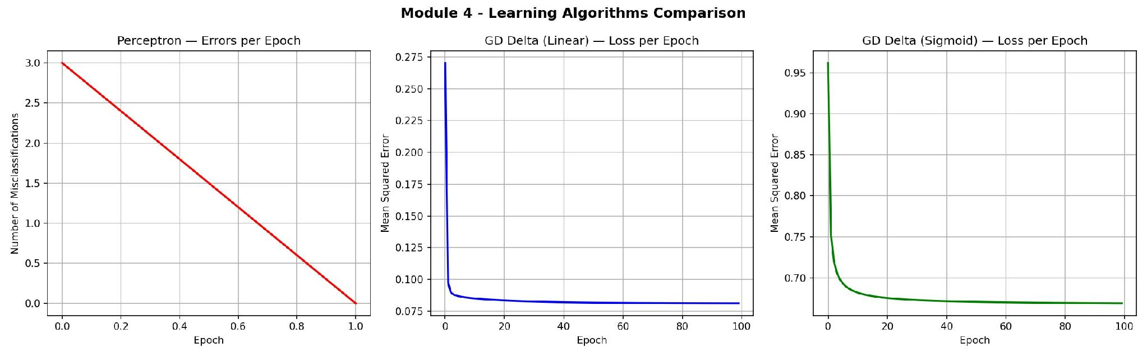

SECTION 8 — Algorithm Comparison

Feature | Perceptron | GD Delta (Linear) | GD Delta (Sigmoid)
Update when? | Wrong predictions only | Every sample always | Every sample always
Activation | Step (hard) | Linear (identity) | Sigmoid (smooth)
Convergence | Only if linearly separable | Always converges | Always converges
Error signal | Right or wrong only | Exact numeric error | Exact numeric error
Learning rate | 0.1 | 0.01 | 0.1

SECTION 9 — Questions & Answers

Q1. Key differences between Perceptron and Gradient Descent Delta Rule?
The Perceptron Learning Rule only updates its weights when it makes a wrong prediction. If the prediction is correct, nothing changes. It uses a step activation function which gives a hard +1 or -1 output with no gradient. This means it only converges if the data is linearly separable.

The Gradient Descent Delta Rule updates weights after every sample, right or wrong. It uses the actual numeric error between expected and computed output. This makes it more stable and always converges even on non-separable data.

Perceptron = updates only on mistakes | Delta Rule = updates always using real error magnitude

Q2. How does activation function choice influence performance?
Step Function (Perceptron): Outputs only +1 or -1. No derivative exists so it cannot be used with gradient-based methods. Works fine for binary linearly separable data.

Linear Function (GD Linear): Outputs the raw net input. Derivative is always 1 so gradient descent is simple. Works well but output is unbounded.

Sigmoid Function (GD Sigmoid): Smooth output between 0 and 1. Well-defined derivative enables precise weight updates. Can suffer from vanishing gradient for extreme inputs.

All three achieved 100% accuracy on Iris since the data is mostly linearly separable. Sigmoid is slightly slower but gives probabilistic outputs.

Q3. Strategies to adjust learning rate for optimal training?
1. Start moderate (0.1) and reduce if loss oscillates instead of decreasing smoothly.
2. Use smaller rates (0.001-0.01) for Sigmoid since its derivative is smaller than linear.
3. Learning Rate Decay: multiply rate by 0.99 after each epoch to gradually reduce it near the optimum.
4. Test multiple rates and compare loss curves — the best rate decreases smoothly without bouncing.

In this project: Perceptron lr=0.1 | GD Linear lr=0.01 | GD Sigmoid lr=0.1 — chosen by observing convergence behavior.

Q4. Implications of different train-test split ratios?
80/20 Split (used here): 80% training gives the model sufficient data to learn. 20% testing provides fair and representative evaluation. Most widely used ratio.

70/30 Split: More test data improves evaluation confidence but slightly reduces training samples. Better when dataset is small.

90/10 Split: More training data but a very small test set may give overoptimistic accuracy estimates since it may not represent all patterns.

With 150 Iris samples, 80/20 gives 120 training and 30 testing samples — a good balance that avoids underfitting and inflated accuracy.

Q5. Challenges encountered and how they were overcome?
Challenge 1 — Perceptron infinite loop: Without a stop condition, non-separable data causes endless looping. Solution: Added max epochs (100) and early stopping when errors = 0.

Challenge 2 — Learning rate tuning in GD: Large rates caused oscillating loss. Solution: Tested 0.001, 0.01, 0.1 and selected the rate giving smoothest loss curve.

Challenge 3 — Sigmoid numerical overflow: Very large inputs can cause exp(-x) overflow. Solution: StandardScaler normalized inputs to prevent extreme values.

Challenge 4 — Binary label conversion: Iris has 3 classes but both algorithms are binary classifiers. Solution: Labels converted to +1 (Setosa) and -1 (Non-Setosa).

Q6. Strengths and limitations of each algorithm?
Perceptron:
Strengths: Very simple. Converges fast on linearly separable data. Minimal math required.
Limitations: Fails on non-separable data. Step function has no gradient so cannot extend to deep networks.

GD Delta Rule — Linear:
Strengths: Always converges. Uses real error for smarter updates. Simple derivative (always 1).
Limitations: Unbounded outputs. Not suitable for probability estimation. Sensitive to learning rate choice.

GD Delta Rule — Sigmoid:
Strengths: Bounded output (0 to 1). Stable gradient. Good for probabilistic classification.
Limitations: Vanishing gradient for extreme inputs. Slower convergence than linear. Needs careful rate tuning.

Conclusion: All three performed equally on the Iris dataset. For complex real-world data, GD Delta with Sigmoid is preferred for stability and bounded outputs.

--- End of Module 4 Submission | Meerab (24F-0729) | Wajeeha Sajid (24F-0806) ---

